Rickmansworth Historical Society
website: https://rickmansworthhistory.org.uk/
e-mail: rick.hist.soc@btinternet.com

Pre-Reformation Wills from Rickmansworth Parish (1409-1539)
edited and with an Introduction by Heather Falvey
xlviii + 219 pages; ISBN 978-0-9544583-5-5
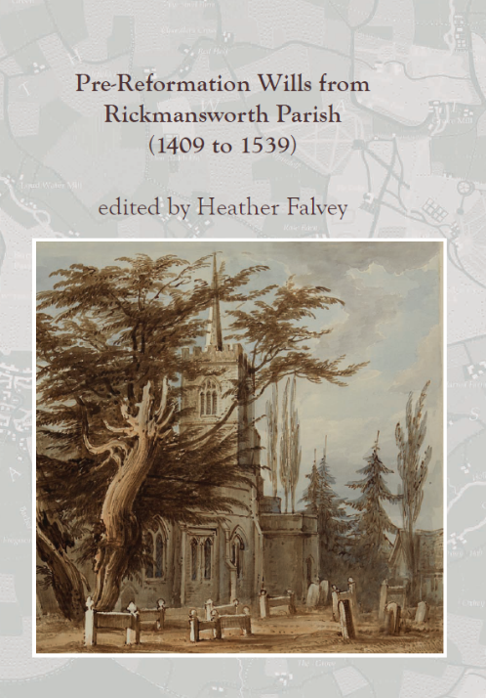
The medieval parish of Rickmansworth covered c.10,000 acres. Its boundary, measuring about 26 miles, encompassed the settlements at Batchworth, Chorleywood, Croxley, Maple Cross, Mill End and West Hyde, as well as Rickmansworth itself.
Medieval wills provide insights into the lives of ordinary people: their religious convictions and piety, family and social networks, wealth, personal and domestic possession and the tools of their trade. In all there are 213 surviving Rickmansworth parishioners’ wills dating from 1409 to 1539 and also 35 grants of administration or simple notes that probate had been granted.
In south-west Hertfordshire a very significant event in the Reformation was the surrender, on 5 December 1539, of St Albans abbey, which not only owned all of the manors, that is the land and housing, in the area but also had the right to appoint the vicar. Hence the last will published in the book is that of the wealthy baker, Thomas Spenser, made on 22 August 1539.
The Introduction discusses medieval wills and medieval Rickmansworth. The number of pre-Reformation probate documents surviving from Rickmansworth is analysed and, by comparison with survivals from elsewhere, it is clear that this is a significant collection. There is a sketch map of the parish, a plan of the church interior in 1825 and a drawing of the north side of that church. There are also four appendixes, a detailed glossary and full indexes of people, places and subjects.

Price £7.50 (+ £3.00 UK p&p) (if more than one copy is required, please enquire about p&p)
Cheques payable to: Rickmansworth Historical Society,
Or pay by bank transfer: Account number: 32051972, Sort Code 60-17-32
Account name: Rickmansworth Historical Scty
For bank transfers, please put your surname and ‘book’ as the reference so that the Treasurer can identify your payment in the Society’s bank account. Please email confirmation of the payment.
……………………………………………………………………………………………………………
Please send orders to: Dr Heather Falvey, Chairman RHS
by post with cheque to: 119 Winton Drive, Croxley Green, Rickmansworth, Herts, WD3 3QS
as email attachment, with confirmation of bank transfer, to: rick.hist.soc@btinternet.com
I enclose a cheque for ……………… or, I have made a bank transfer of ……………………..
Please send me ……. copy/copies of Pre-Reformation Wills from Rickmansworth Parish
Name …………………………………………………………………………………..…………………..
Address ………………………………………………………………………………………….…………
………………………………………. (phone/email in case of query) …………………………………….

